**NAAN MUTHALVAN**

**DIGITAL MARKETTING**

**GNANAMANI COLLEGE OF TECHNOLOGY**

**TEAM LEADER:** Ishwarya M

**TEAM MEMBERSE:** Aarthi P

Barani S

Kaviyarasi R

Papitha P

**Procedure of our project in step by step.**

**STEP 1:**

Create an Analytic account to collect and organize data.

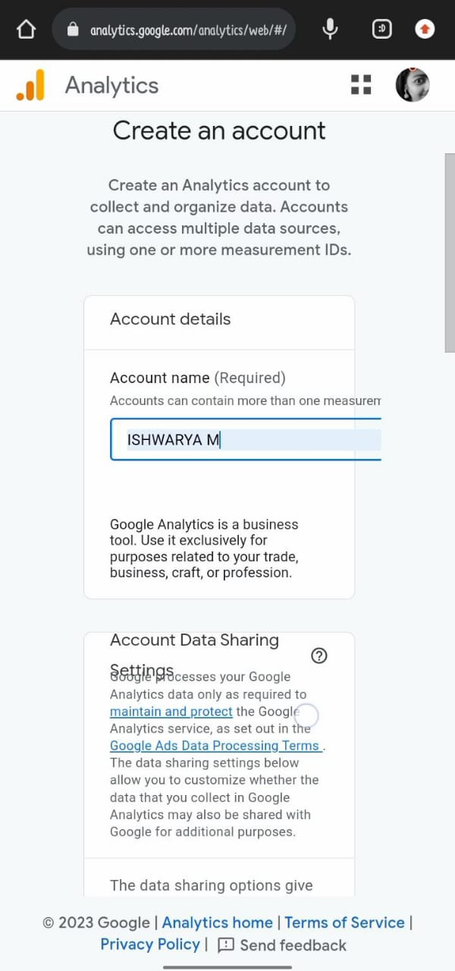

STEP 2:

Enter the property details, country and currency.

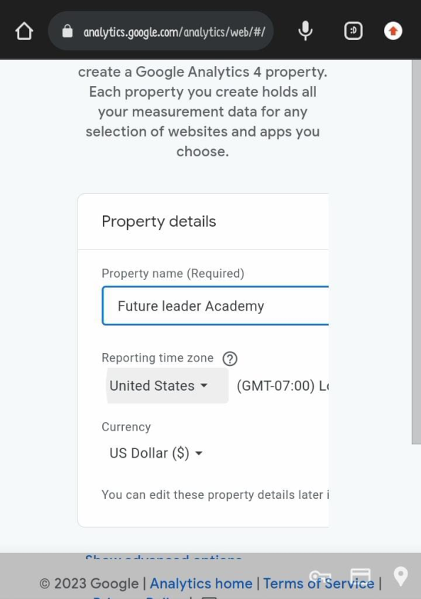 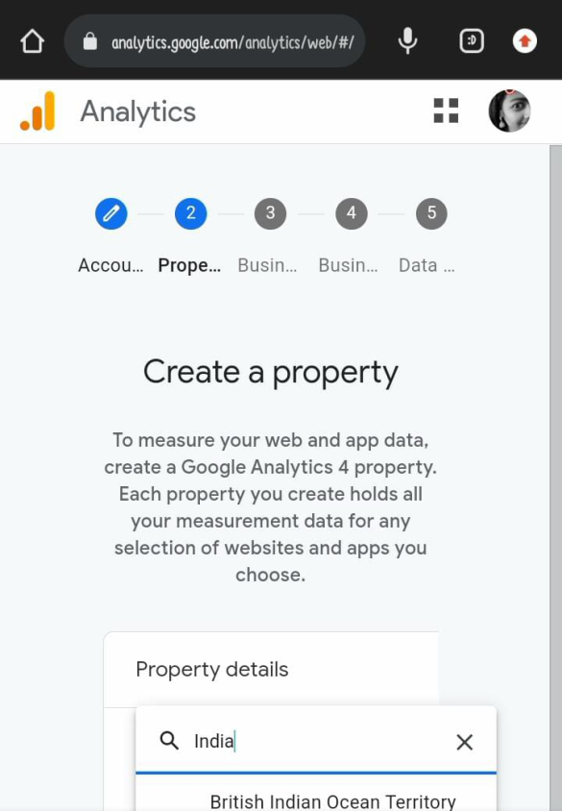

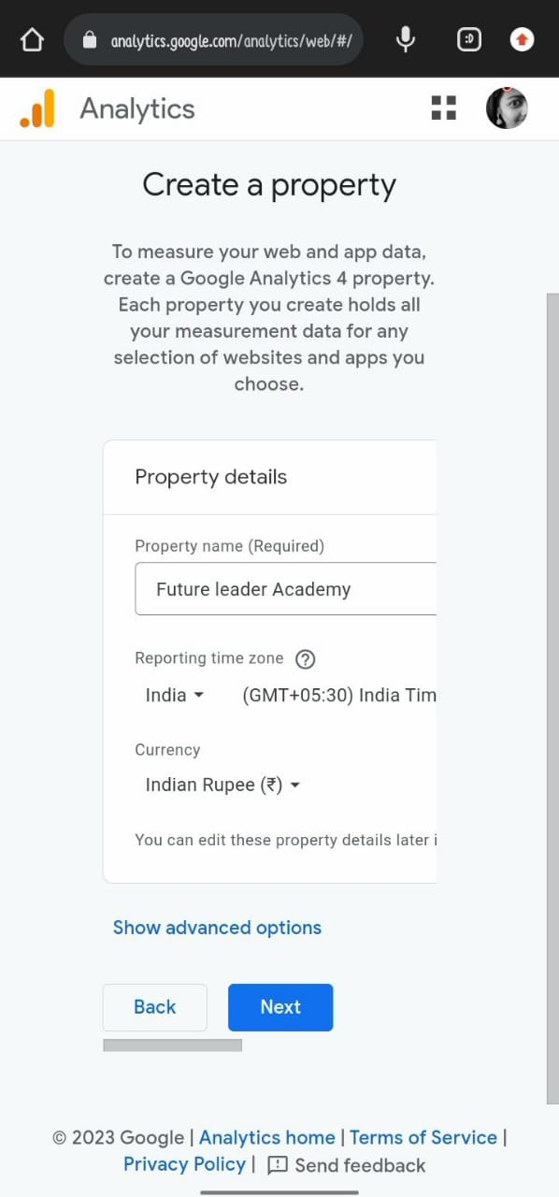

**STEP 3:**

Enter your business details like Industry category and business size.

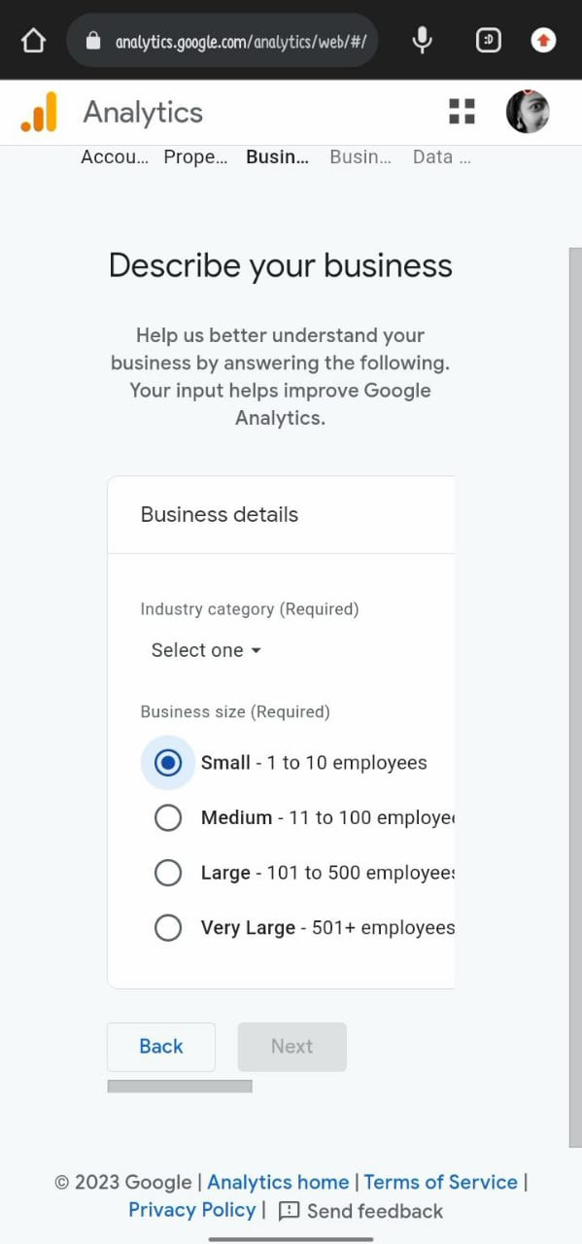

STEP 4: Select the topics most important to you.

**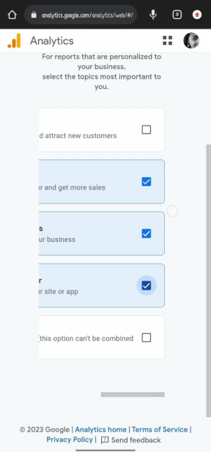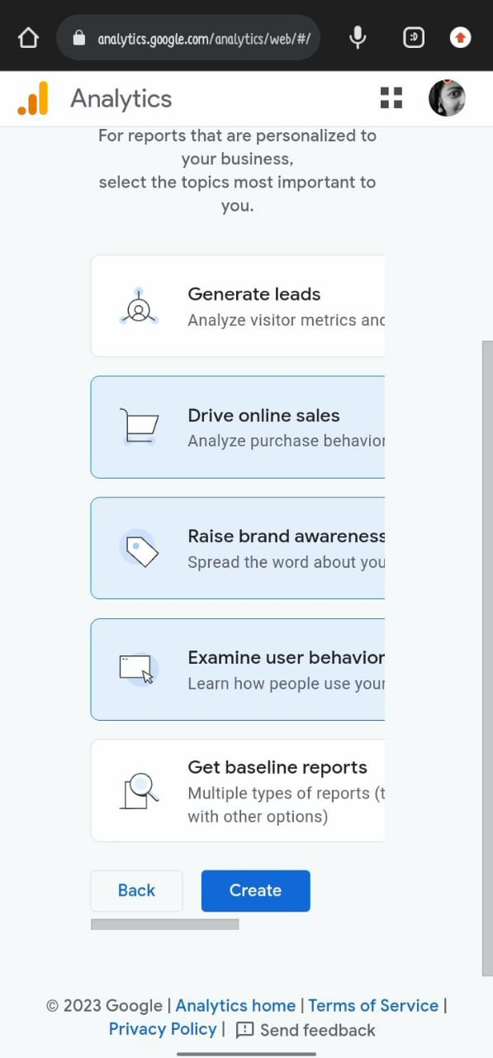  
STEP 5:**

To use Google Analytics you must first accepts the terms of service agreement for your country / region.

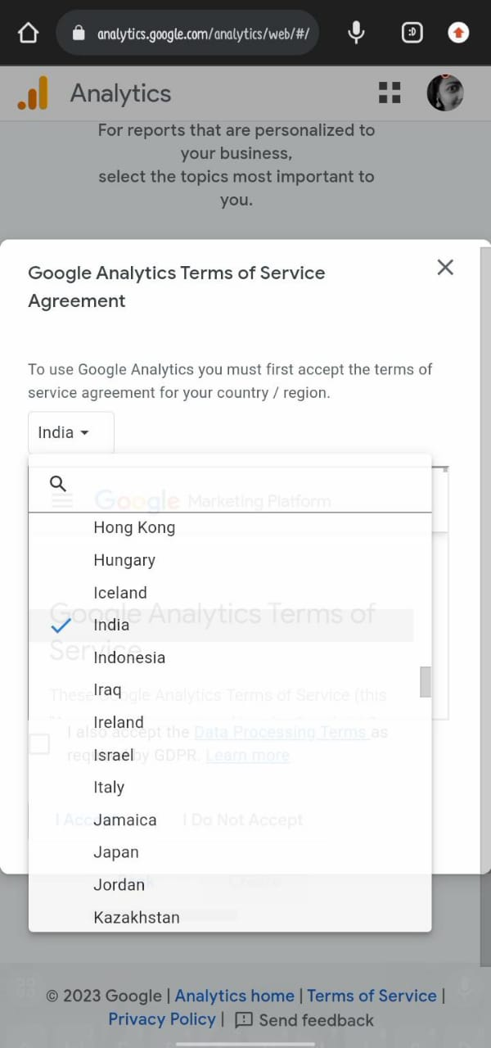 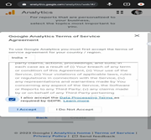

**STEP 6:** Choose a platform

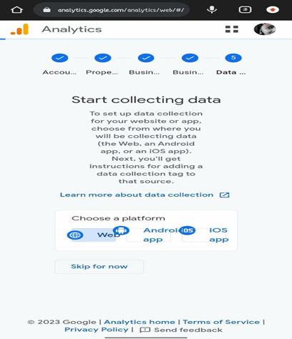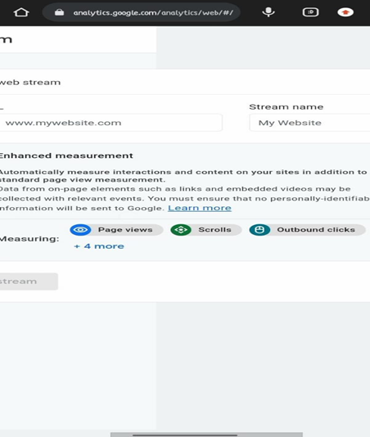

**Step 7:** Create stream, view the steam details. (G-YKPLPZ9VVG)

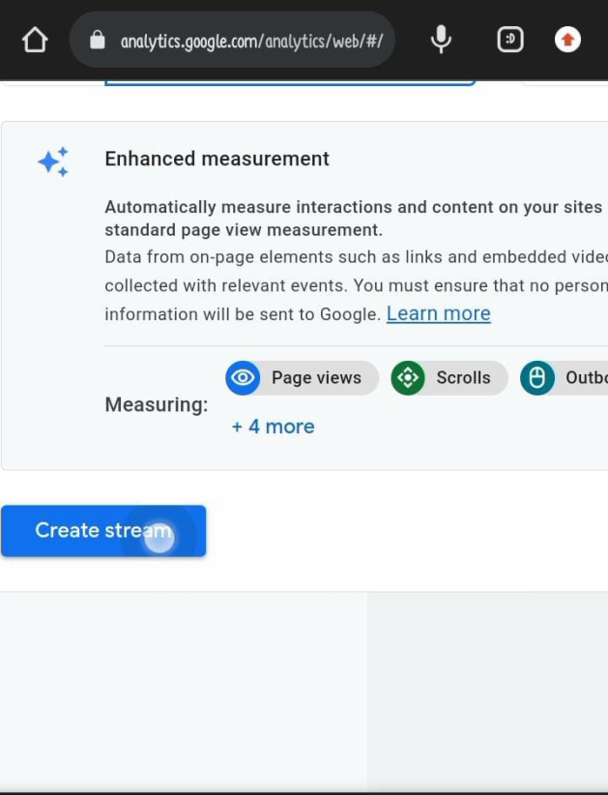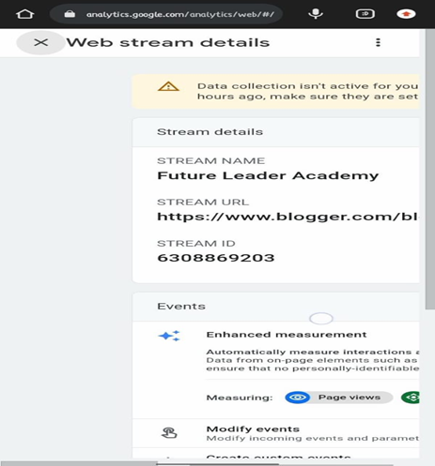  
**STEP 8:** Immediately, installation instruction is deliver the code. The code was copied.

<https://www.googletagmanager.com/gtag/js?id=G-YKPLPZ9VVG>

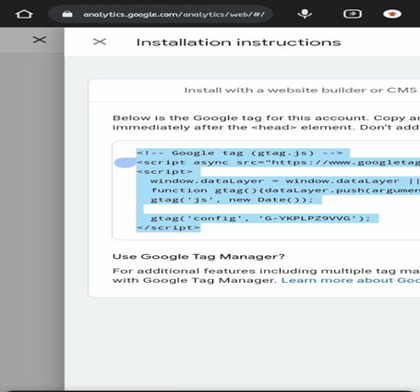

**STEP 8:** Then the code was paste the website by the header site and then copy the page like URL link. Next it was upload to the Git Hub.

<https://www.blogger.com/blog/themes/edit/6542387029289941789>

